A close up of a sign

Description generated with high confidence

# Order Batch Processor

Index

Order Batch Processor 1

**I.** **Introduction** 3

**II.** **Architecture and Project** 3

**III.** **Package And Installation** 5

**IV.** **Uninstall Program** 7

**V.** **Publish new deployment package** 8

**VI.** **User Interface** 11

**VII.** **Commands** 13

**VIII.** **Order Batch Format** 14

## **Introduction**

Order Batch Processor is an application that calculates boutiques orders commissions provided by a csv file.

## **Architecture and Project**

* Order Batch Processor is Windows Console Application in .NET Framework 4.7.1, developed in Visual Studio 2017, with Onion Ring Architecture for logic segregation and decoupling.

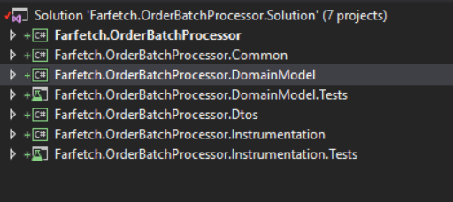

* Dependencies are injected via Ninject Container and when possible Task base asynchronous operations where implemented.
* A Logging Manager is provided, that writes traces and exceptions in event viewer and Units testing was implemented for Domain Model and Instrumentation Layer.

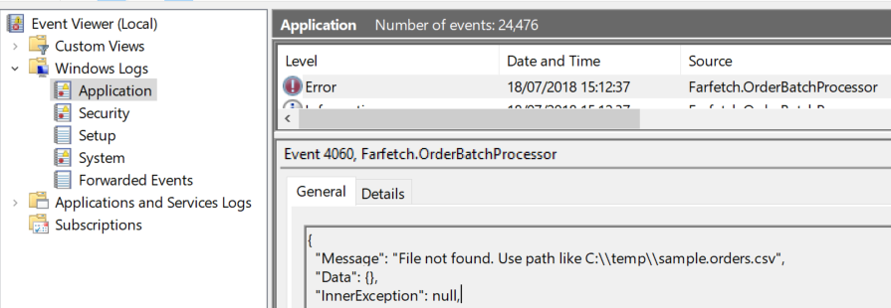

* Multiple Nuget packages were used to support operations above.
* Farfect.OrderBatchProcessor is a console application layer that provides user interfacetdo customers. To run the project from Visual Studio Solution, right click in Farfect.OrderBatchProcessor project and select “Set as StartUp Project” and press “Start” on Visual Studio top bar

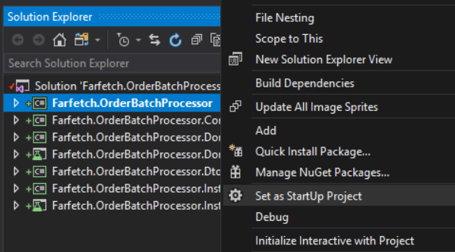

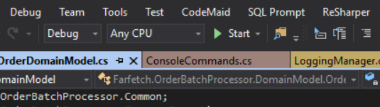

**NOTE**: To open the project solution in Visual Studio, please use “Run as Administrator”.

Order Batch Processor writes traces and exceptions in event viewer and elevated permissions are necessary.

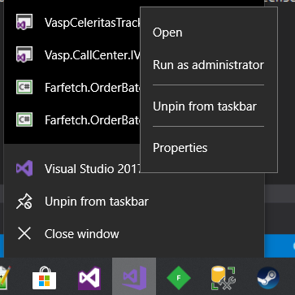

## **Package And Installation**

An installation package is provided in the “Deploy” folder

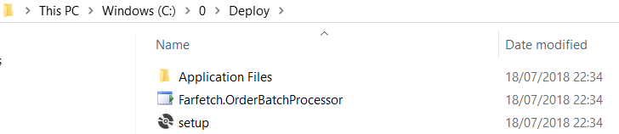

**Package installation**

1. Click right mouse button in “setup” file and select “Run as administrator”;

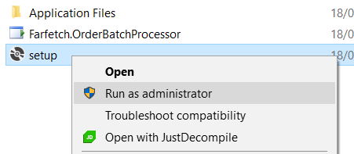

1. In the prompt window, select “Install”;

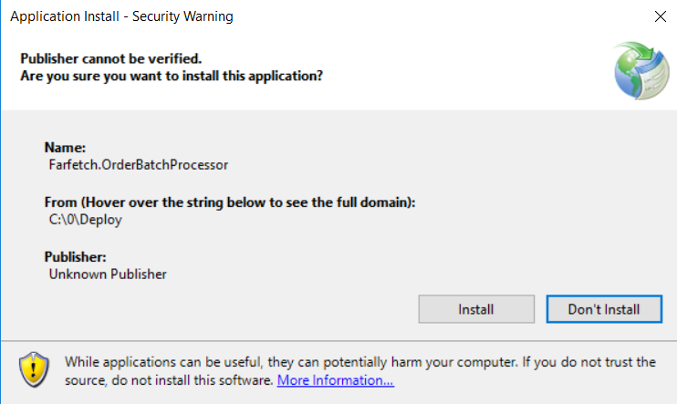

1. After installation, the application will be up and running;

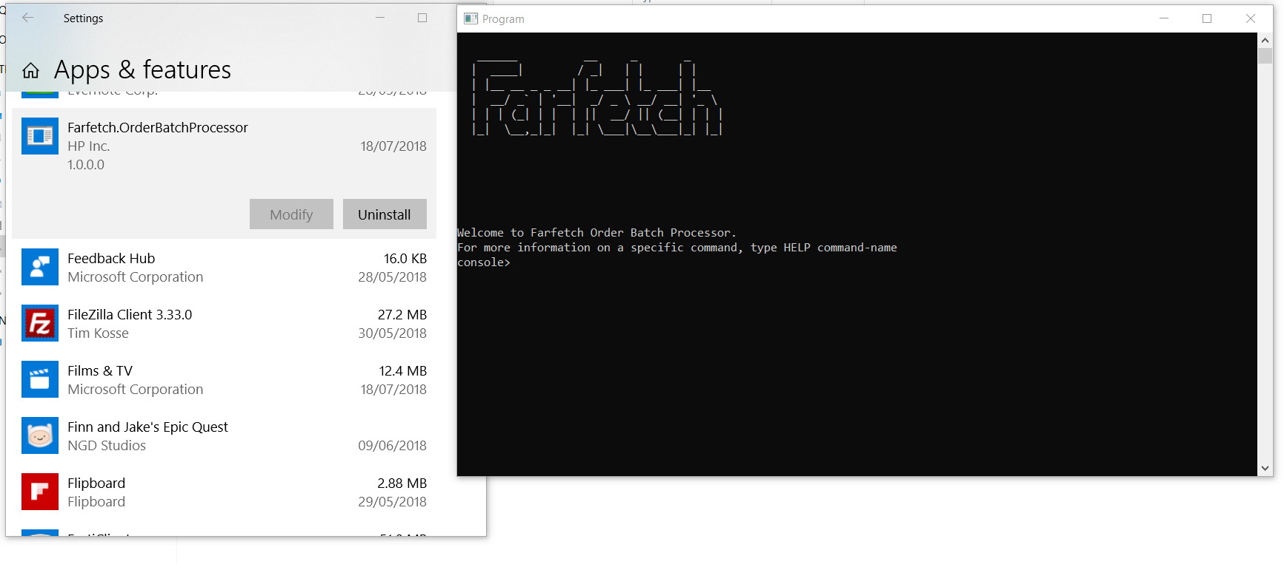

1. Pin in windows task bar for future usage:

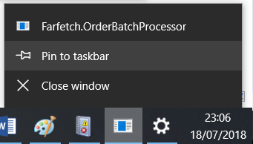

## **Uninstall Program**

1. To uninstall and if in Windows 10, go to App & features, look for Farfetch.OrderBatchProcessor and select “Uninstall”;

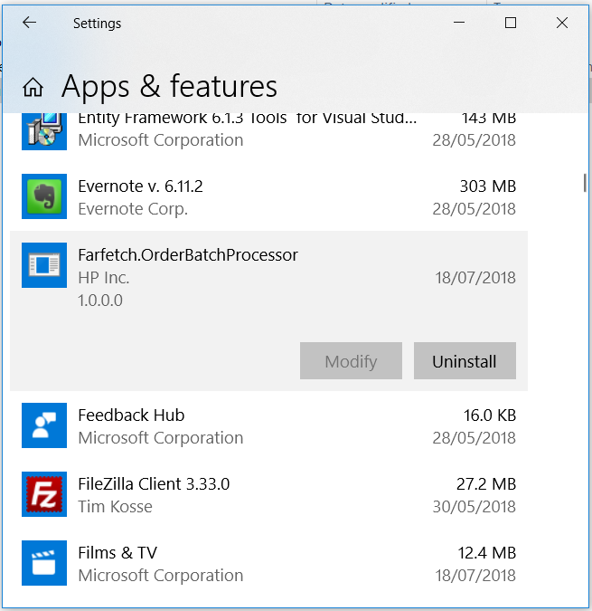

1. User will be prompt to “Remove the application from this computer” and select “Ok”;

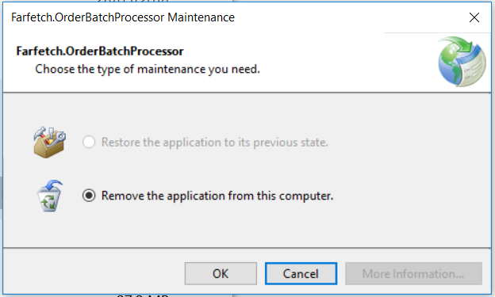

## **Publish new deployment package**

1. To publish a new package from the project solution, right click on Farfetch.OrderBatchProcessor and select “Publish”:

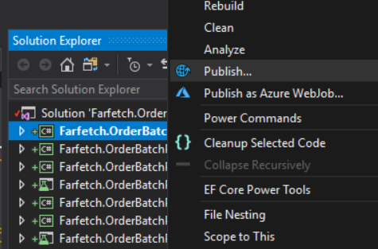

1. Select a folder to deploy and select “Next”:

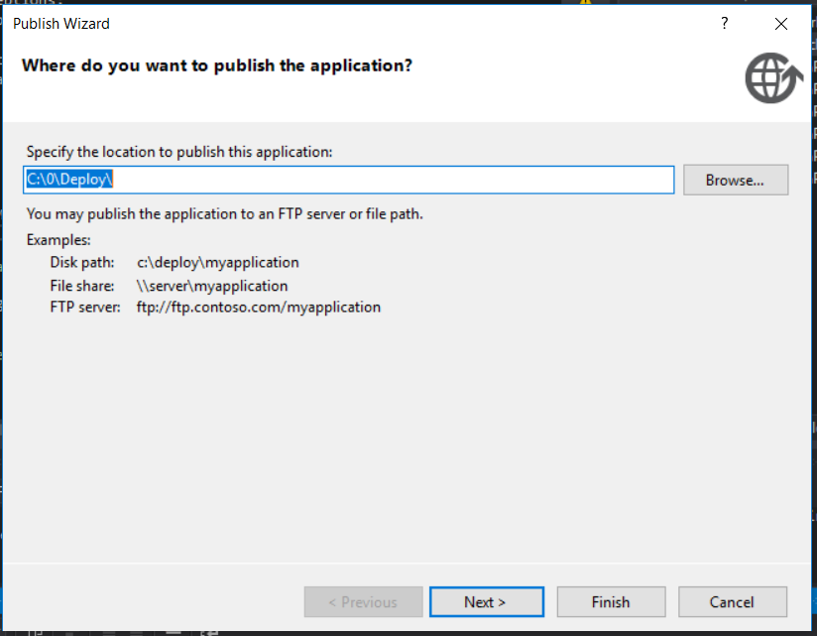

1. Select “From a CD-ROM or DVD_ROM” option and select “Next”;

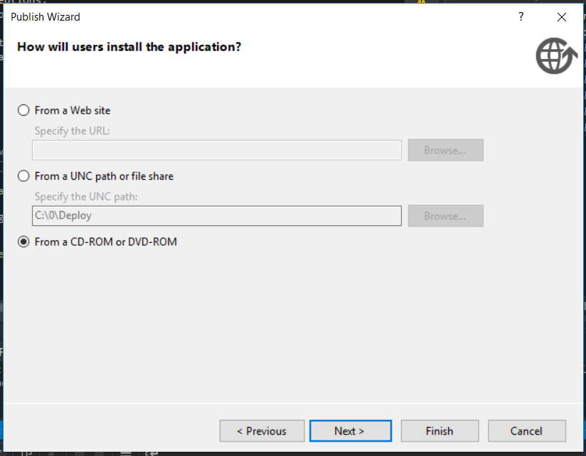

1. Select “The application will not check for updates” option and select “Finish”;

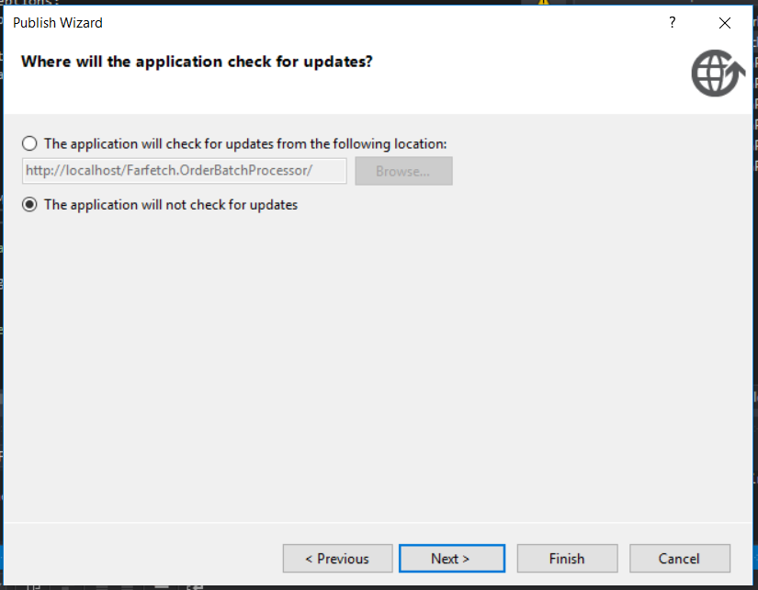

## **User Interface**

* User interface is console application with simplistic layout for an easy experience.
* Write OrderBatch command followed by a path for a csv file in the current format C:\temp\sample.orders.csv and the console application will print the total commissions foreach boutique.

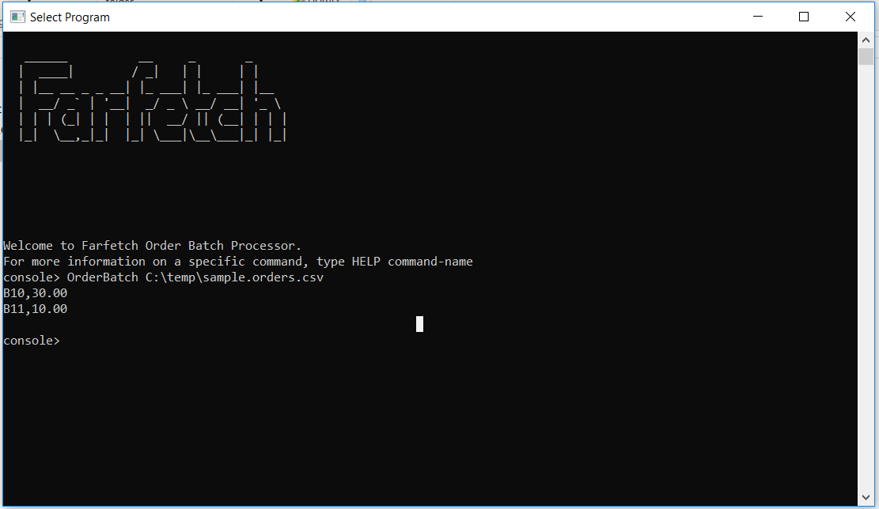

* HELP command is provided for more information on a specific command.

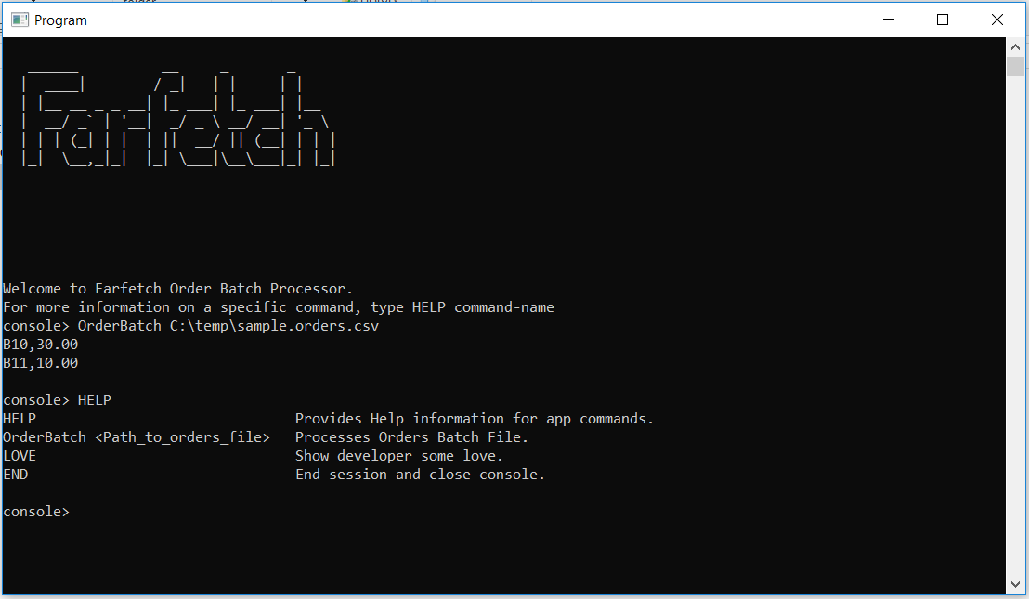

## **Commands**

* HELP Provides Help information for app commands.
* OrderBatch <Path_to_orders_file> Processes Orders Batch File.
* LOVE Show developer some love.
* END End session and close console.

## **Order Batch Format**

* Batch must be in CSV format;
* Line structure must be <Boutique_ID>,<Order_ID>,<TotalOrderPrice>
* Example:

B11,O1001,100.00

B10,O1002,200.00

B10,O1003,300.00

#### EDITION

Farfetch

DATA

JULY 2018